CodeReview AI
AI-Powered Code Review & Rewrite Platform

Project Description
CodeReview AI is an AI-powered code review and code-improvement web application that helps developers analyse, evaluate, and optimize source code snippets using Large Language Models (LLMs). The platform allows a user to paste or upload a piece of code, choose which type of review to run, and receive a structured, AI-generated report covering bugs, performance issues, security vulnerabilities, and best-practice violations.
Beyond raising issues, CodeReview AI can also generate a complete, production-ready rewrite of the submitted code, present the improvements it made, and let the user compare the original and rewritten versions side by side. Every review a user runs is saved to their personal account, so past reviews can be revisited at any time through a review history panel.
The application is built as a full-stack Next.js (App Router) project with TypeScript. Authentication is handled with NextAuth using an email/password credentials flow, review data is persisted with Prisma ORM against a SQLite database, and AI analysis is performed through the Gemini 2.5 Flash model, accessed via the z-ai-web-dev-sdk. The UI is built with React 19, Tailwind CSS, and shadcn/ui components, with Zustand managing client-side state.
By combining a clean, focused single-page workflow with structured AI reasoning, CodeReview AI turns code review from a manual, time-consuming task into an instant, guided, and explainable process.

Introduction
Code review is one of the most important yet time-consuming parts of the software development lifecycle. It helps catch bugs early, enforce coding standards, and improve the overall quality and security of a codebase. However, manual code review requires an experienced reviewer, takes considerable time, and can be inconsistent from one reviewer to another.
At the same time, Large Language Models (LLMs) such as Google's Gemini have become capable of reading source code, reasoning about its correctness, and producing detailed, structured feedback in seconds. This creates an opportunity to automate the first pass of a code review — surfacing bugs, performance bottlenecks, security risks, and style issues instantly, before a human reviewer even looks at the change.
CodeReview AI was built to take advantage of this capability. Rather than replacing a developer's judgement, it acts as an always-available first-pass reviewer: a developer pastes their code, chooses what kind of feedback they want, and receives an organized report they can act on immediately, along with an optional AI-generated rewrite that already applies the fixes.

Problem Statement
Developers frequently write and modify code without immediate access to a peer reviewer, which means bugs, inefficient logic, and security flaws can go unnoticed until much later in the development cycle, when they are more expensive to fix. Manual review is also inconsistent — different reviewers focus on different things, and small projects or solo developers often skip structured review altogether.
Existing AI coding assistants are often focused on code generation and autocompletion rather than structured review. Few tools clearly separate findings by category (bugs, performance, security, best practices), rank them by severity, explain the reasoning behind each issue, and then offer a ready-to-use corrected version of the code in the same workflow.
There is a need for a lightweight, focused tool that lets a developer paste any snippet of code, choose exactly which kind of analysis they want, and receive fast, categorized, and actionable feedback — along with the option to see an improved rewrite — without switching between multiple separate tools.

Proposed Solution
CodeReview AI addresses this gap by providing a single, focused web application where a user signs in, pastes or uploads a code file, selects one or more review dimensions (bugs, performance, security, best practices, rewrite), and submits it for AI analysis.
The backend constructs a detailed, category-specific system prompt, sends the code to the Gemini 2.5 Flash model, and parses the model's structured JSON response into a normalized list of findings, each tagged with a category and severity. If a rewrite was requested, the AI also returns a complete optimized version of the code along with an explanation of the changes, which is displayed using a side-by-side diff-style panel. Every completed review, along with its findings and statistics, is saved to the user's account for later reference.

Objectives
- To let developers submit source code and receive an AI-generated review without manual setup or configuration.
- To automatically classify findings into bugs, performance issues, security vulnerabilities, and best-practice violations.
- To rank every finding by severity (critical, high, medium, low, info) so developers can prioritize fixes.
- To generate a complete, production-ready rewrite of the submitted code when requested.
- To let users compare original and AI-rewritten code and understand the reasoning behind each change.
- To securely authenticate users and persist their review history for future reference.
- To support review of code written in a wide range of programming languages.

Scope
- Allow users to register and sign in using an email and password.
- Provide a code editor area where a user can paste code directly or upload a code file.
- Support 17 languages/formats including JavaScript, TypeScript, Python, Java, Go, Rust, C++, C#, Ruby, PHP, Swift, Kotlin, SQL, HTML, CSS, React/JSX, and Vue.
- Let users toggle which review dimensions to run: bug detection, performance, security, best practices, and code rewrite.
- Send the code and chosen options to an AI model and generate a structured JSON report.
- Display a summary score, category counts, and a filterable list of findings with descriptions and suggested fixes.
- Generate and display an optimized code rewrite with an explanation and a list of improvements made.
- Persist every review (code, findings, rewrite, and statistics) to a database tied to the logged-in user.
- Provide a review history panel so users can revisit and reload past reviews.
- Support both light and dark themes across the interface.

System Design

System Overview
CodeReview AI follows a full-stack, server-rendered architecture built entirely within a single Next.js application. Next.js's App Router is used both for the client-facing UI and for server-side API routes, so there is no separate backend service to deploy — the frontend, the API layer, the authentication layer, and the database access layer all live inside one project.
The client (browser) renders the React interface, holds the code editor state in a Zustand store, and calls Next.js API routes over standard HTTP requests. The API routes validate the authenticated session, build a prompt for the AI model, call the Gemini 2.5 Flash model through the z-ai-web-dev-sdk, parse and normalize the AI's JSON response, persist the result to the SQLite database using Prisma, and return the structured result back to the client for rendering.

System Workflow
- The user opens the application and signs in (or registers a new account) using the email/password credentials form.
- The user pastes code into the editor or uploads a code file, and selects the programming language.
- The user toggles which review options to run: Bug Detection, Performance, Security, Best Practices, and/or Code Rewrite.
- The user submits the code for review.
- The Next.js API route (/api/review) verifies the user's session and builds a category-specific system prompt describing exactly what to look for.
- The prompt and code are sent to the Gemini 2.5 Flash model via the z-ai-web-dev-sdk.
- The AI model returns a structured JSON response containing a summary, a list of findings, and (if requested) a rewritten version of the code.
- The API route parses and normalizes the response, computes counts per category, and saves the review to the database against the user's account.
- The frontend receives the result and renders a summary banner, a category-filterable findings list, and — if generated — a side-by-side comparison of the original and rewritten code.
- The completed review is added to the user's review history, which can be reopened at any time from the history panel.

Functional Modules

Authentication Module
- Allows users to register with a name, email, and password.
- Hashes and verifies passwords using bcrypt.
- Issues and validates JWT-based sessions using NextAuth.

Code Input Module
- Provides a text editor area for pasting code.
- Supports uploading a code file from the user's device.
- Provides a language selector covering 17 languages/formats.
- Includes a built-in sample snippet so users can try the tool immediately.

Review Options Module
- Lets the user toggle five review dimensions on or off: bugs, performance, security, best practices, and rewrite.

AI Review Engine
- Dynamically builds a system prompt based on the selected review options.
- Sends the code to the Gemini 2.5 Flash model for analysis.
- Extracts and repairs JSON from the AI's response, even if wrapped in markdown or extra text.
- Normalizes category and severity values so the output is always consistent.

Results Panel Module
- Displays an overall quality grade (A+ to D) based on the number and severity of findings.
- Shows counts of bugs, performance issues, security issues, and best-practice issues.
- Lets users filter findings by category using tabs.
- Displays each finding's title, description, severity, affected code snippet, and suggested fix.

Code Rewrite & Diff Module
- Displays the AI-generated optimized version of the submitted code.
- Shows a syntax-highlighted, side-by-side comparison of the original and rewritten code.
- Lists the specific improvements made and explains the reasoning behind the rewrite.

Review History Module
- Persists every review to the database, linked to the logged-in user.
- Lets users browse, reopen, and review their past submissions.

System Architecture

Overview
CodeReview AI uses a unified full-stack architecture powered by the Next.js App Router. Instead of separate frontend and backend applications communicating over a network boundary, the UI components and the API route handlers exist in the same codebase and are compiled and served together. This simplifies deployment while still keeping a clear separation of responsibilities between presentation (React components), state management (Zustand), business logic (API routes), data access (Prisma), and the AI service layer.
When a request needs authentication, data persistence, or AI analysis, the client calls one of the Next.js API routes. Each route independently validates the session, performs its task, and returns a JSON response, keeping the system modular even though it is deployed as a single application.

Architecture Components

Frontend (Client)
Built with React 19 and Next.js's App Router, styled with Tailwind CSS and shadcn/ui components. It renders the code editor, review options, results panel, and review history, and communicates with the backend using the browser's fetch API through NextAuth's session-aware client hooks.

State Management
Zustand is used to manage the code review workflow state on the client — the current code, selected language, chosen review options, in-progress/loading status, the AI result, and the loaded review history — without prop drilling between components.

API Layer (Next.js Route Handlers)
Server-side route handlers under src/app/api implement registration, authentication, code review submission, and review history retrieval. Each route runs on the server, so API keys and database access never reach the browser.

Authentication Layer
NextAuth is configured with a Credentials provider that verifies the user's email and bcrypt-hashed password against the database and issues a JWT session. All protected routes check for a valid session before performing any action.

AI Service Layer
The z-ai-web-dev-sdk client is used to call the Gemini 2.5 Flash model. A prompt builder dynamically assembles category-specific instructions based on the user's selected review options, and a response parser extracts, cleans, and validates the JSON returned by the model.

Data Layer
Prisma ORM is used to define and query the data model against a SQLite database. Two models are defined: User (name, email, hashed password, and related reviews) and CodeReview (title, language, code, findings, rewrite, summary, and per-category issue counts, linked to the owning user).

Technology Stack
CodeReview AI is built using a modern, TypeScript-first full-stack web technology stack:
Technology | Category | Purpose
Next.js 16 (App Router) | Full-Stack Framework | Provides both the React frontend and the server-side API routes in a single application.
React 19 | UI Library | Builds the interactive, component-based user interface.
TypeScript | Programming Language | Adds static typing across frontend, backend, and data models for reliability.
Tailwind CSS | CSS Framework | Provides utility-first, responsive styling across the application.
shadcn/ui + Radix UI | Component Library | Supplies accessible, pre-built UI primitives such as dialogs, tabs, dropdowns, and switches.
Zustand | State Management | Manages client-side state for the code editor, review options, results, and history.
NextAuth.js | Authentication | Handles credentials-based login, session issuance, and route protection.
bcryptjs | Security | Hashes and verifies user passwords before storing them.
Prisma ORM | Database ORM | Defines the data schema and provides type-safe database queries.
SQLite | Database | Stores user accounts and code review records.
z-ai-web-dev-sdk | AI SDK | Provides the client used to call the AI model from the server.
Gemini 2.5 Flash | Large Language Model | Performs the AI-powered code analysis, issue detection, and rewriting.
Zod | Schema Validation | Validates form and request data structures.
React Hook Form | Form Management | Manages login and registration form state and validation.
react-syntax-highlighter | UI Library | Renders syntax-highlighted code in the editor and diff view.
Framer Motion | Animation | Provides smooth transitions and animated UI states.
Lucide React | Icon Library | Supplies consistent icons throughout the interface.
Git & GitHub | Version Control | Tracks source code changes and hosts the project repository.

Implementation

Frontend Implementation
The frontend is implemented as a single-page client experience within the Next.js App Router (src/app/page.tsx). It is composed of focused, reusable components: a CodeEditor for entering or uploading code, ReviewOptions for toggling review dimensions, a ResultsPanel for displaying AI findings, FindingsCard and CodeDiff for rendering individual results and rewrites, and ReviewHistory for browsing past reviews.
Global client state — the current code, selected language, chosen options, loading state, AI result, and review history — is managed centrally with Zustand (src/store/code-review.ts), keeping components simple and avoiding prop drilling. Tailwind CSS and shadcn/ui components are used throughout for a consistent, responsive, theme-aware interface with full light/dark mode support via next-themes.

Authentication Implementation
User registration is handled by a dedicated API route (/api/auth/register) that validates the input, checks for an existing account, hashes the password with bcrypt, and creates the user record. Login is handled by NextAuth's Credentials provider (src/lib/auth.ts), which looks up the user by email, verifies the password hash, and issues a JWT session containing the user's id, name, and email. Every protected API route calls getServerSession to confirm the request is authenticated before proceeding.

AI Review Engine Implementation
The core of the application is the /api/review route. When a review is submitted, the route dynamically builds a system prompt (buildSystemPrompt) that only includes instructions for the categories the user selected — for example, bug detection instructions are only added if the 'bugs' option is enabled. This keeps the AI focused and reduces irrelevant output.
The prompt instructs the model to return a single JSON object containing a short summary, an array of findings (each with an id, category, severity, title, description, affected line, code snippet, and suggestion), and, if a rewrite was requested, a rewrite object containing the original code, the rewritten code, an explanation, and a list of specific improvements.
Because LLM output can sometimes include extra text or markdown code fences, the route includes an extractJSON helper that tries a direct parse, then strips markdown fences, then scans for a balanced top-level JSON object, and finally falls back to a regular-expression match — ensuring the response is reliably parsed even if the model's formatting varies slightly. A normalization step then guarantees that every finding has a valid, expected category and severity value.

Data Persistence Implementation
Once the AI response is parsed and normalized, the review is saved to the database using Prisma. The CodeReview model stores the title, language, original code, the findings array (serialized as JSON text), the rewrite object (if any), the summary, and per-category issue counts, linked to the authenticated user's id. This allows the review history feature to later retrieve and display all of a user's past reviews (/api/reviews and /api/reviews/[id]).

Results & Rewrite Display Implementation
On the client, the ResultsPanel renders a summary banner with a letter grade derived from the number and severity of findings, followed by category counts and a tab-based filter (All, Bugs, Performance, Security, Best Practices). Each finding is rendered as a card showing its severity, description, affected code, and suggested fix. If a rewrite was generated, the CodeDiff component displays the AI's explanation, a list of improvements, and a syntax-highlighted view of the rewritten code so the user can compare it against the original.

User Workflow
- The user registers or logs in with an email and password.
- The user pastes or uploads code and selects the programming language.
- The user selects which review dimensions to run and clicks submit.
- The backend authenticates the request, builds the AI prompt, and calls the Gemini 2.5 Flash model.
- The AI's structured response is parsed, normalized, and saved to the database.
- The frontend displays the summary, categorized findings, and (if requested) the rewritten code with an explanation.
- The review becomes available in the user's review history for future reference.

Implementation Summary
The implementation combines a single Next.js codebase, a typed Prisma/SQLite data layer, NextAuth-based authentication, and the Gemini 2.5 Flash model to deliver an end-to-end AI code review experience without requiring a separate backend service. Careful prompt engineering and robust JSON extraction make the AI's output reliable and consistent, while a clean component and state-management structure on the frontend keeps the user experience fast and easy to follow.

Results
The following screenshots show CodeReview AI running end-to-end: the main interface, a code submission with review options selected, the AI-generated findings, the optimized rewrite, the light theme, and the mobile-responsive layout.
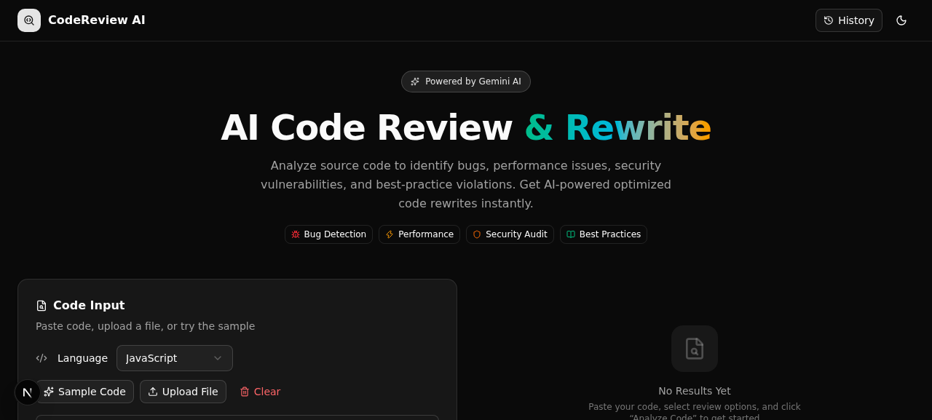
Fig 1. Home screen — code editor, language selector, and review options .
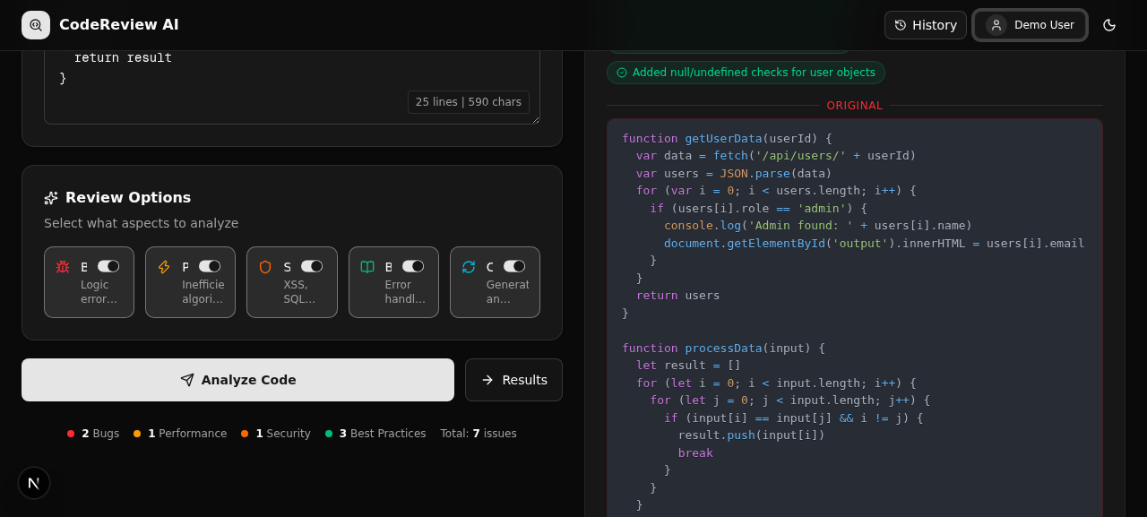
Fig 2. Sample code loaded into the editor with review options selected, ready for submission.
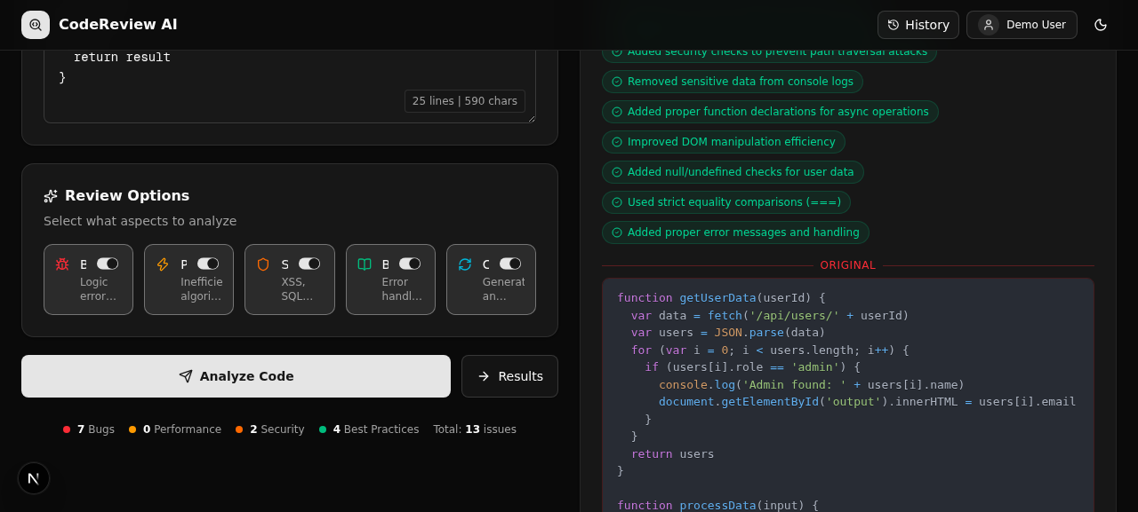
Fig 3. AI-generated results panel showing the quality grade, category counts, and detected bugs with severity and suggested fixes.
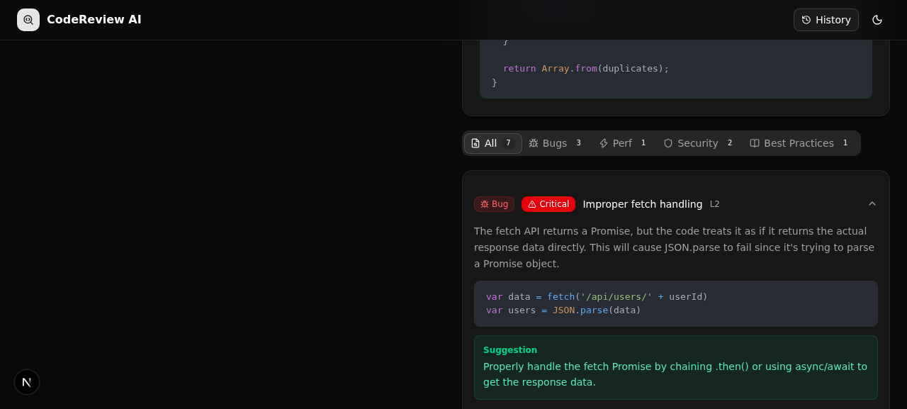
Fig 4. Full review results including the AI-generated optimized code rewrite.

Conclusion
CodeReview AI successfully demonstrates how Large Language Models can be integrated into a practical developer tool to automate the first pass of code review. By combining category-specific AI prompting, structured JSON output, and a clear, filterable results interface, the application turns what is normally a slow, manual process into an instant, guided, and explainable one.
The system's use of a unified Next.js architecture — with authentication, AI processing, and data persistence all handled through server-side API routes — keeps the application simple to build, deploy, and maintain, while still supporting a rich, multi-feature client experience. The addition of AI-generated rewrites and a persistent review history further extends the tool's usefulness beyond a single one-off analysis.
Overall, CodeReview AI achieves its goal of providing developers with a fast, structured, and trustworthy AI-assisted code review and improvement tool that can be used on any snippet, in any of the supported languages, at any time.

